

**Advance Web Application Development**

**Task 12**

**Forms**

Instructor:

**Tahir Shafi**

Prepared By

**Noman Asif**

**Code**

**Style.CSs**

*{

  font-family: 'Gill Sans', 'Gill Sans MT', Calibri, 'Trebuchet MS', sans-serif;

}

body{

    background-color: dodgerblue;

}

.container {

    display: flex;

    justify-content: center;

    align-items: center;

    height: 100vh;

  }

  .form {

    background-color:azure;

    text-align: center;

    padding: 20px;

    border: 1px solid #ccc;

    border-radius: 5px;

    box-shadow: rgba(0, 0, 0, 0.24) 0px 3px 8px;

    width: 20%;

  }

  .form h2 {

    margin-top: 0;

  }

  .form input {

    margin-bottom: 10px;

    padding: 10px;

    width: 100%;

    box-sizing: border-box;

  }

  .form button {

    background-color: #4CAF50;

    color: white;

    padding: 10px 20px;

    border: none;

    border-radius: 5px;

    cursor: pointer;

  }

  .form button:hover {

    background-color: #45a049;

  }

**loginform.html**

<!DOCTYPE html>

<html lang="en">

<head>

  <meta charset="UTF-8" />

  <meta name="viewport" content="width=device-width, initial-scale=1.0" />

  <title>Task 12 - Forms</title>

  <link rel="stylesheet" type="text/css" href="styles.css">

</head>

<body>

  <!-- Task 12 -->

  <!-- Make a login and signup form on different pages that

  should be displayed in the center of the page using CSS

  and html -->

  <div class="container">

    <form class="form">

      <div style="text-align: center;">

        <img src="https://online.umt.edu.pk/img/UMT_Logo.png" alt="logo" width="100" />

      </div>

      <h2>Login To Panel</h2>

      <input type="text" placeholder="Username" required>

      <input type="password" placeholder="Password" required>

      <button type="submit">Login</button>

      <br/>

      <p>Don't Have a Account. <a href="signup.html">Sign Up</a></p>

    </form>

  </div>

</body>

</html>

**Signup.html**

<!DOCTYPE html>

<html lang="en">

<head>

    <meta charset="UTF-8" />

    <meta name="viewport" content="width=device-width, initial-scale=1.0" />

    <title>Task 12 - Forms</title>

    <link rel="stylesheet" type="text/css" href="styles.css">

</head>

<body>

    <!-- Task 12 -->

    <!-- Make a login and signup form on different pages that

  should be displayed in the center of the page using CSS

  and html -->

    <div class="container">

        <form class="form">

            <div style="text-align: center;">

                <img src="https://online.umt.edu.pk/img/UMT_Logo.png" alt="logo" width="100" />

            </div>

            <h2>Sign Up Now</h2>

                <input type="text" placeholder="Username" required>

                <input type="email" placeholder="Email" required>

                <input type="password" placeholder="Password" required>

                <input type="password" placeholder="Re-Type Password" required>

                <button type="submit">Sign Up</button>

                <br />

                <p>Don't Have a Account. <a href="loginform.html">Sign In</a></p>

        </form>

    </div>

</body>

</html>

**Result**

**Login Form**

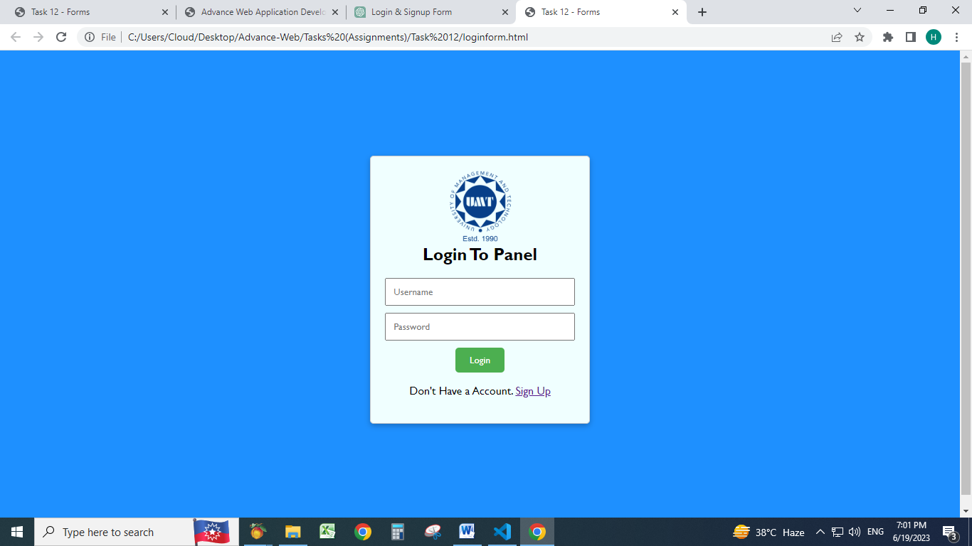

**Sign Up Form**

